**This tool can be used to perform test triaging and compares results with**

**previous build**

**Setup required before in local running this tool:**

1. All **triage folder HTML files** which are executed part of sweep needs to be placed in one folder (like shown in below image

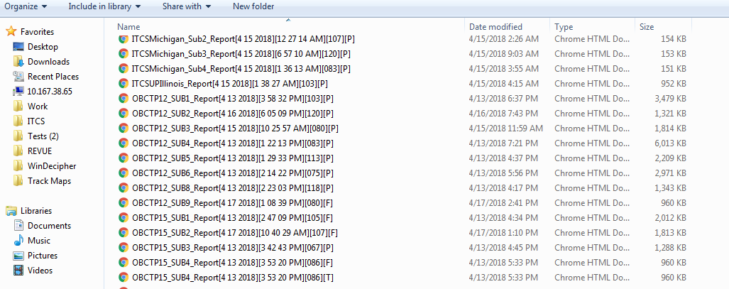

**Figure: Screen 1**

1. All previous build html files from **acceptable runs** need to be placed in local folder (like shown in below image).

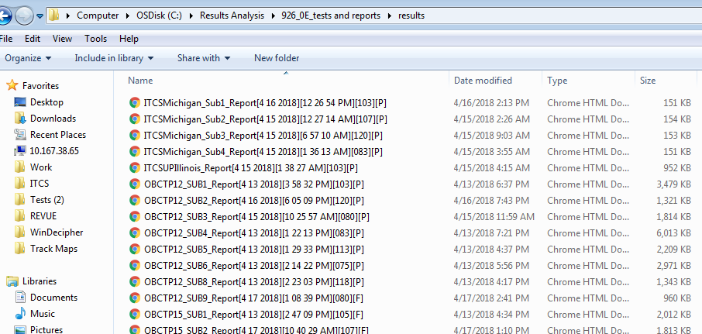

**Figure: Screen 2**

**Procedure to run this tool:**

1. Copy “**TestTriagingApp**” folder to local PC from path **\\10.167.38.65\File Share\Masthan\Tools\.**
2. Double **c**lick on the application “**TestTriagingApp.exe**” placed in folder “TestTracking_tool”. Following window will be popped up.

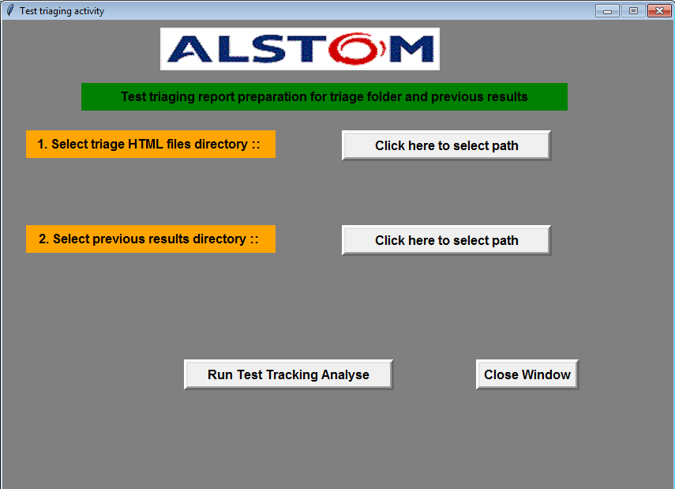

**Figure: Screen 3**

1. Now supply following inputs to tool
2. Click on button “Click here to select path” to the path where all **triage** **HTML** files are placed in local directory. For example path shown in above Screen1.
3. Click on button “Click here to select path” to the path where all **previous build acceptable** **results** files are placed in local directory. For example path shown in above Screen2.

After filling above said fields screen looks like this.

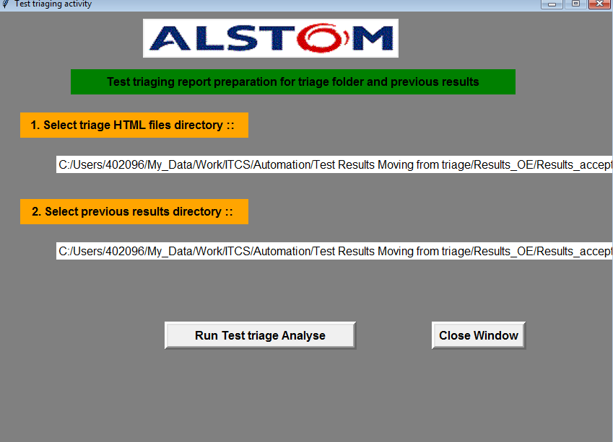

1. Now click on the button “Run Test triage Analysis”.
2. After test analysis start you will see the test execution status at bottom of window as shown in below image.

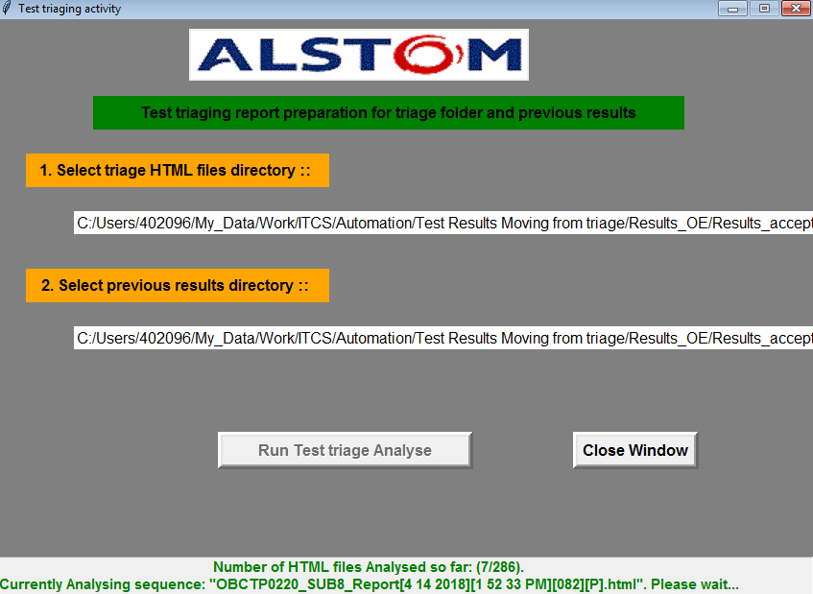

1. Once test execution complete, then information dialog box comes up and that shows where the results sheet placed. Test results workbook name will be like **“TestResultsSheet_Day_hour_minute_sec”.xlsx.**

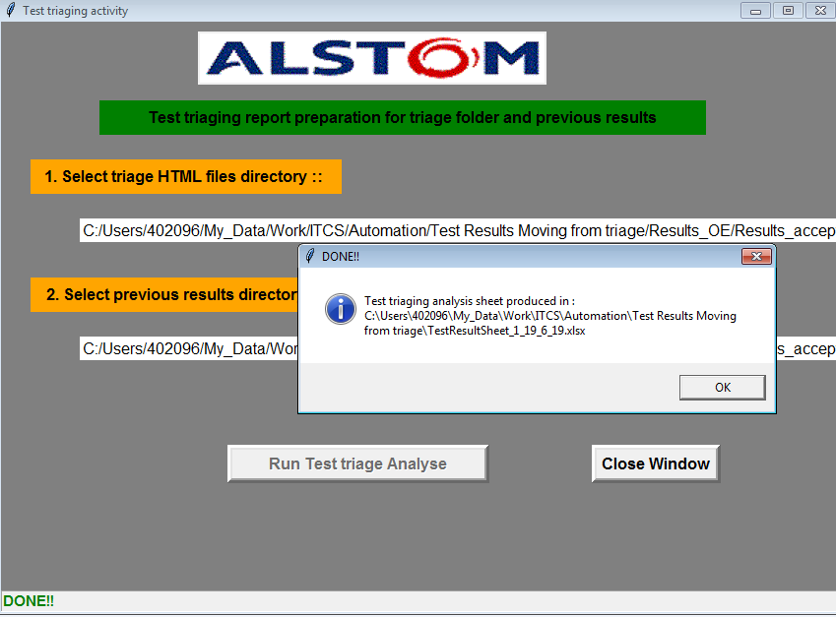

1. Final test tracking sheet with results produced like shown below.

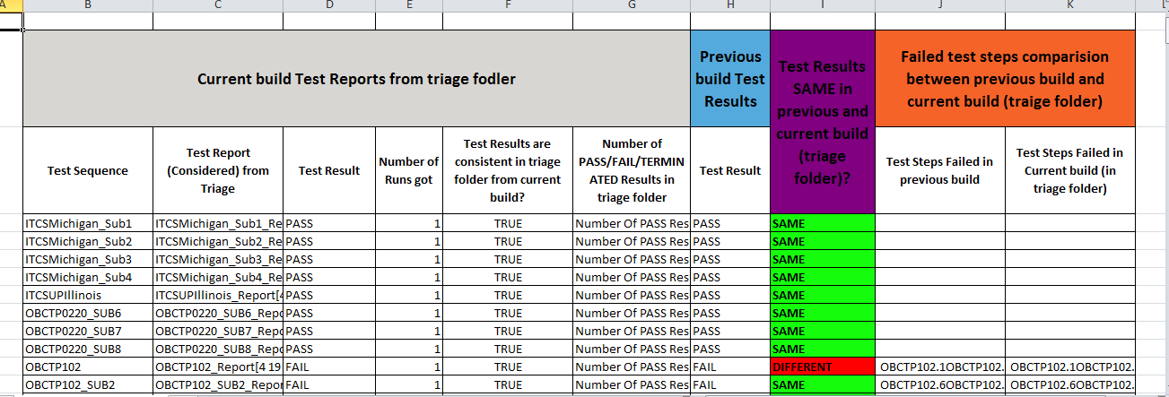

**Following are the checks tool does:**

**Note: To explain better I taken OBC150_SUB1 as example in below points.**

1. In triage folder, if “OBCTP150_SUB1” has “FAIL”, “PASS” results, then tool reports the results status as **inconsistent** in the results sheet and **FAIL report** will be considered to compare it with previous build results. Also reports how many runs we got for every test.
2. Now tool goes back to previous build report of test “OBCTP150_SUB1” and sees whether it is PASS or FAIL or REPORT available or not.
3. If test “OBCTP150_SUB1” is FAIL, then tool compares FAIL report from triage folder and previous build report and gives the report as results SAME or NOT. Also tool gives which test steps failed in previous build and triage folder.
4. If previous build doesn’t have results of “OBCTP150_SUB1”, then tool reports saying no results for this test “OBCTP150_SUB1” in previous build
5. NOTE: Make sure **previous build results path** doesn’t have duplicate results like “OBCTP150_SUB1” test results with FAIL and PASS results. Because tool doesn’t know which file to pick to compare with triage folder path results.
6. If test “OBCTP150_SUB1” has only terminated results, then tool reports saying ONLY TERMINATED results available.

Please look at attached sheet to see the report and above listed points how it is visible in report.

